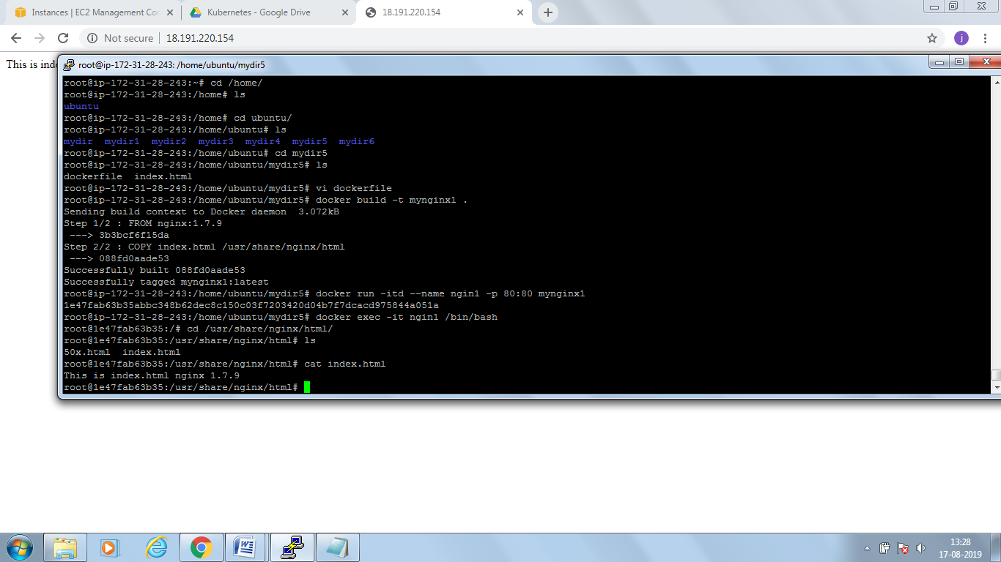

1 cd /usr/share/nginx/html/

2 ls

3 cat index.html

4 history

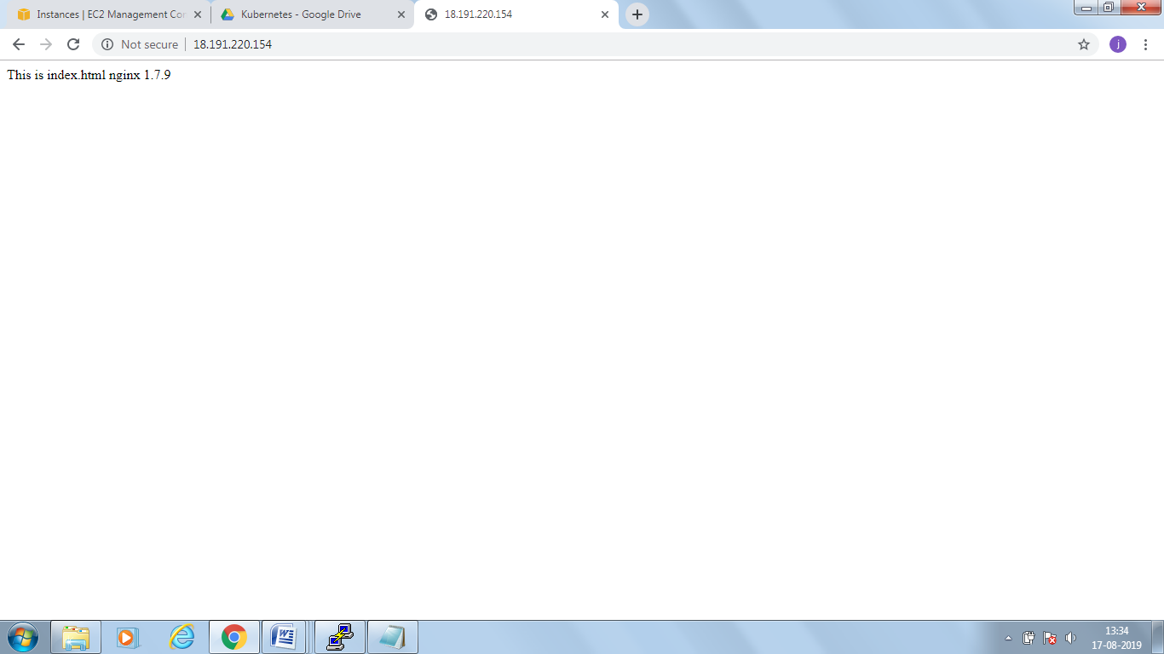

========= today

186 mkdir mydir5

187 ls

188 cd mydir5

189 vi dockerfile.yml

190 vi index.html

191 docker build -t myimage01 .

192 ls

193 mv dockerfile.yml dockerfile

194 docker build -t myimage01 .

195 vi dockerfile

196 docker build -t myimage01 .

197 docker images

198 docker run -itd --name mynginx 3b3bcf6f15da /bin/bash

199 dcoker ps -a

200 docker ps -a

201 docker images

202 cd usr/share/nginx

203 cd usr

204 cd -

205 ls

206 mkdir mydir6

207 cd mydir6

208 vi dockerfile

209 vi index.html

210 docker build -t nginx:1.9.1

211 docker build -t nginx:1.9.1 .

212 docker images

213 cd -

214 cd mydir5

215 docker build -t nginx:1.7.9 .

216 docker images

217 cd -

218 docker images

219 cd mydir5

220 docker exec -itd myimage01 /bin/bash

221 docker run -itd --name mycontainer05 3b3bcf6f15da /bin/bash

222 ls

223 cat index.html

224 docker images

225 docker ps -a

226 cd -

227 ls

228 cd mydir3

229 ls

230 cd -

231 cd mydir4

232 ls

233 cat myapache.yml

234 cd -

235 docker run -itd -p 10001:80 nginx

236 cd mydir5

237 ls

238\*

239 docker exec -it mynginx5

240 docker exec -it mynginx5 /bin/bash

241 ls

242 cat index.html

243 vi dockerfile

244 cd

245 docker images

246 docker rmi -f dockerfile nginx

247 docker images

248 docker rmi -f myimage01

249 docker rmi -f nginx

250 docker images

251 cd /home/

252 ls

253 cd ubuntu/

254 ls

255 cd mydir5

256 ls

257 vi dockerfile

258 docker build -t mynginx1 .

259 docker run -itd --name ngin1 -p 80:80 mynginx1

260 docker exec -it ngin1 /bin/bash

261 history

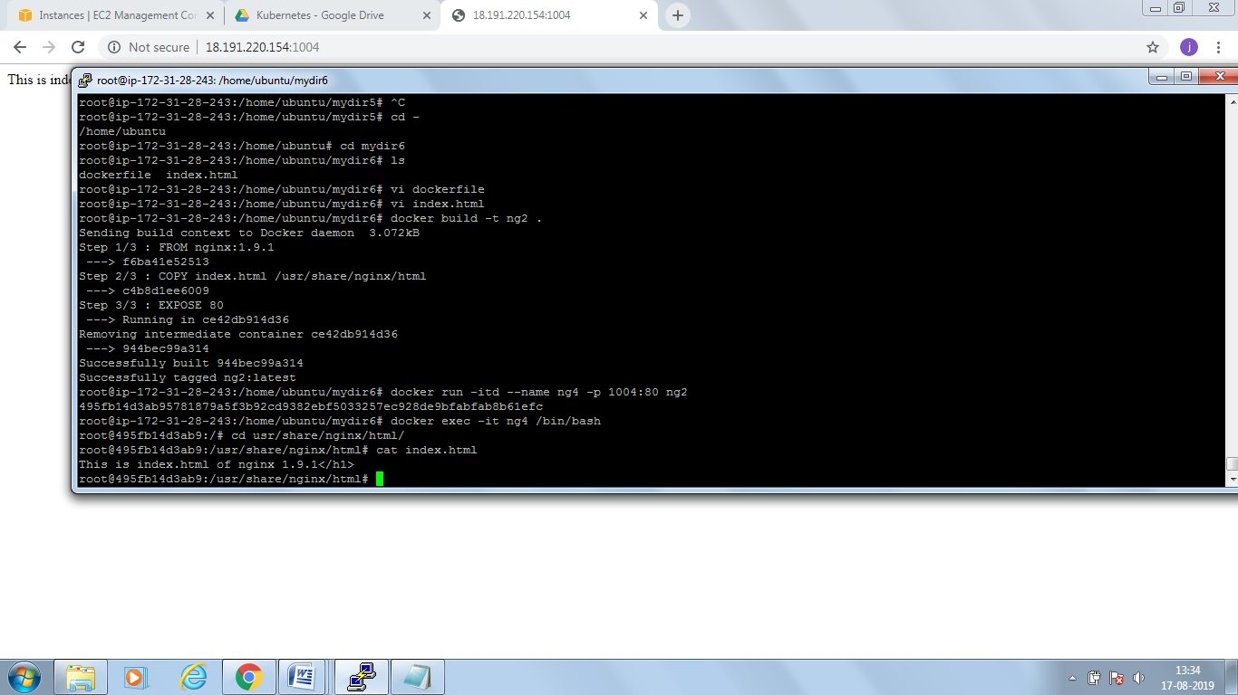

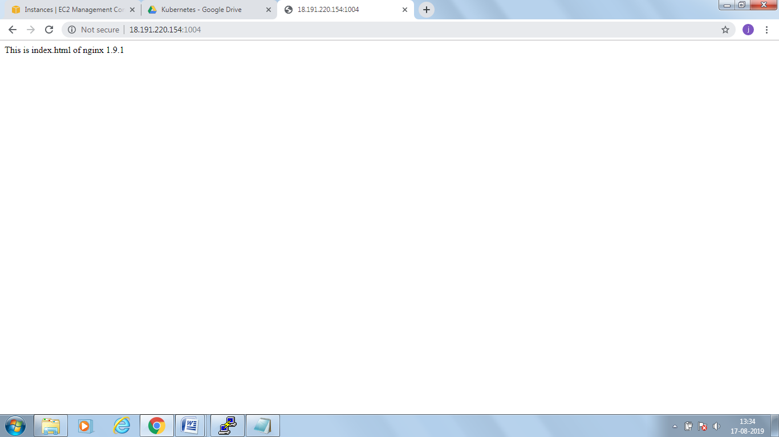

At home

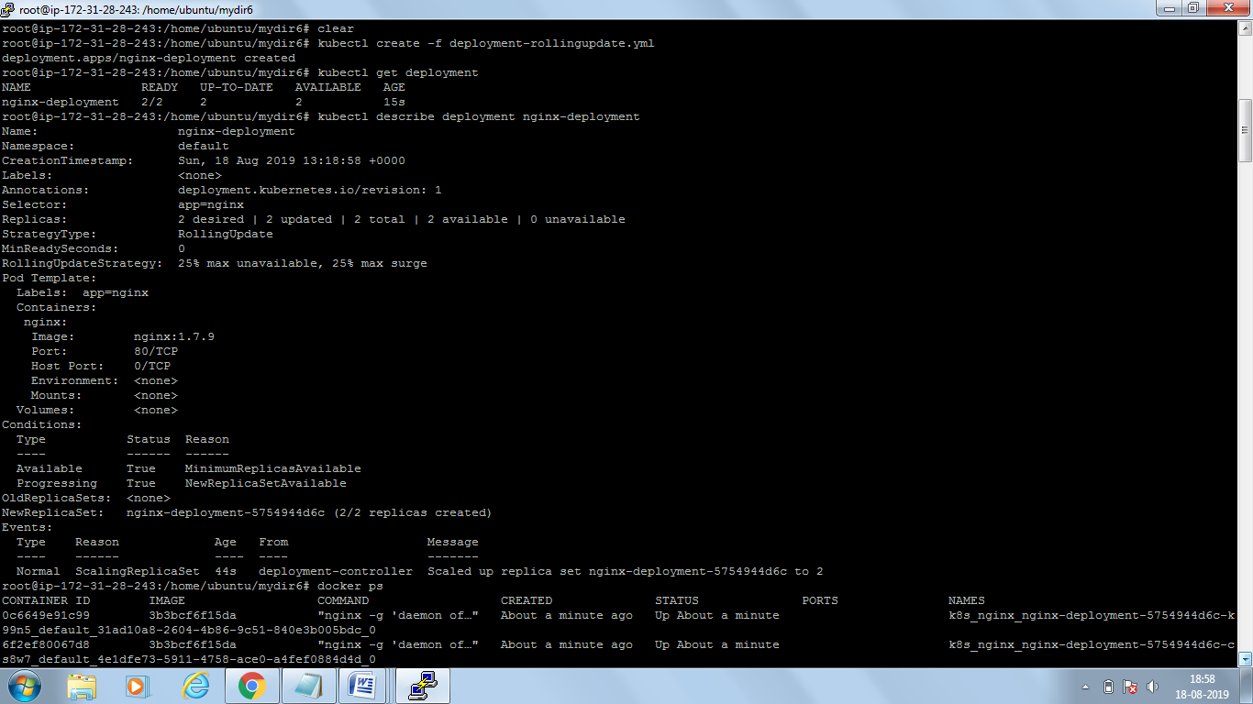

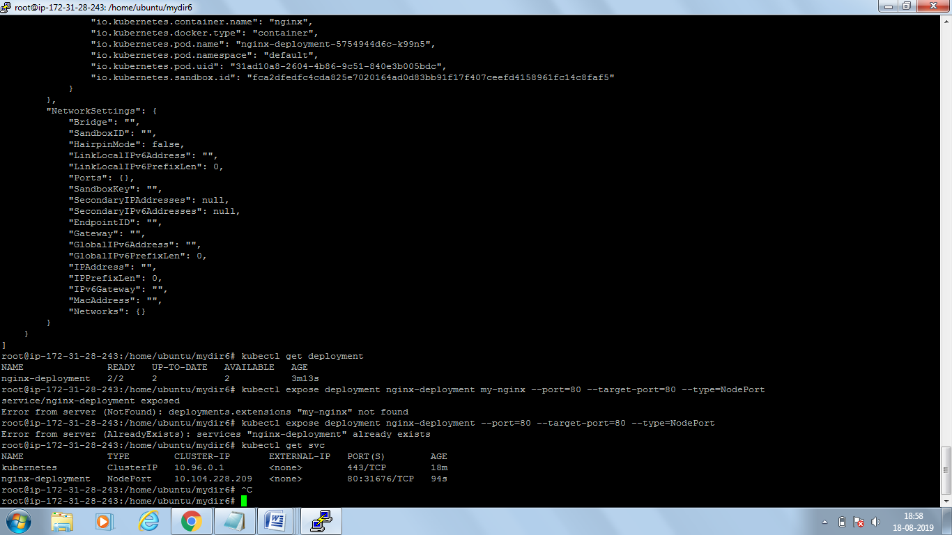

kubectl describe pods nginx-deployment-5754944d6c-cs8w7

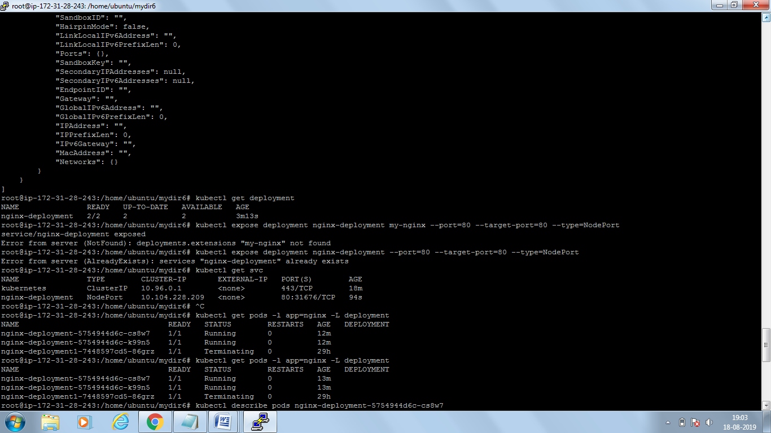

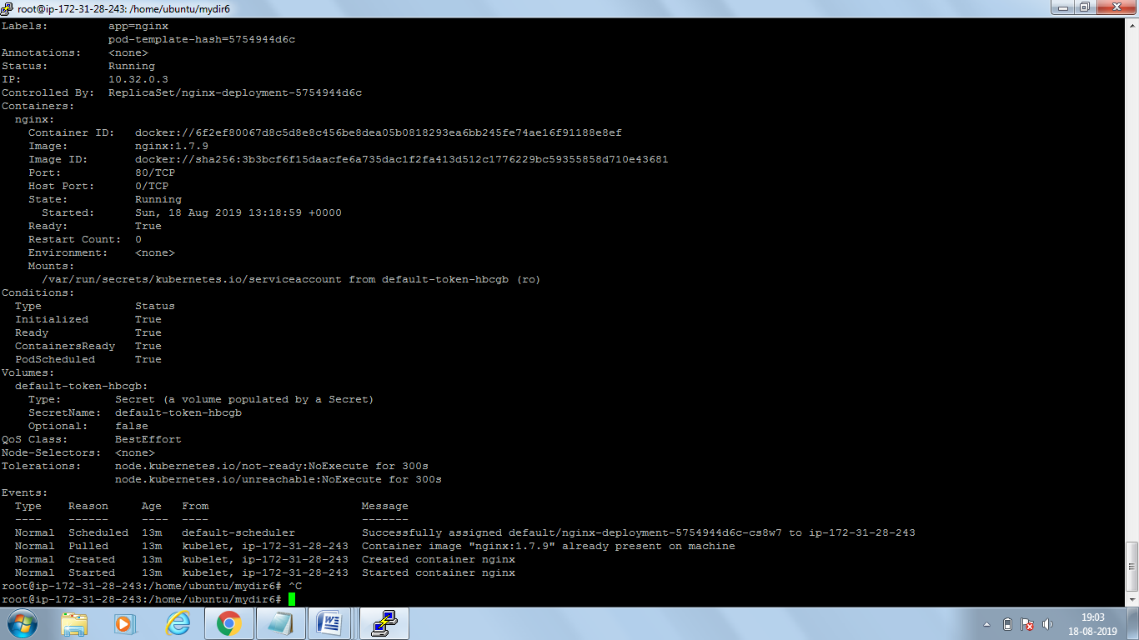

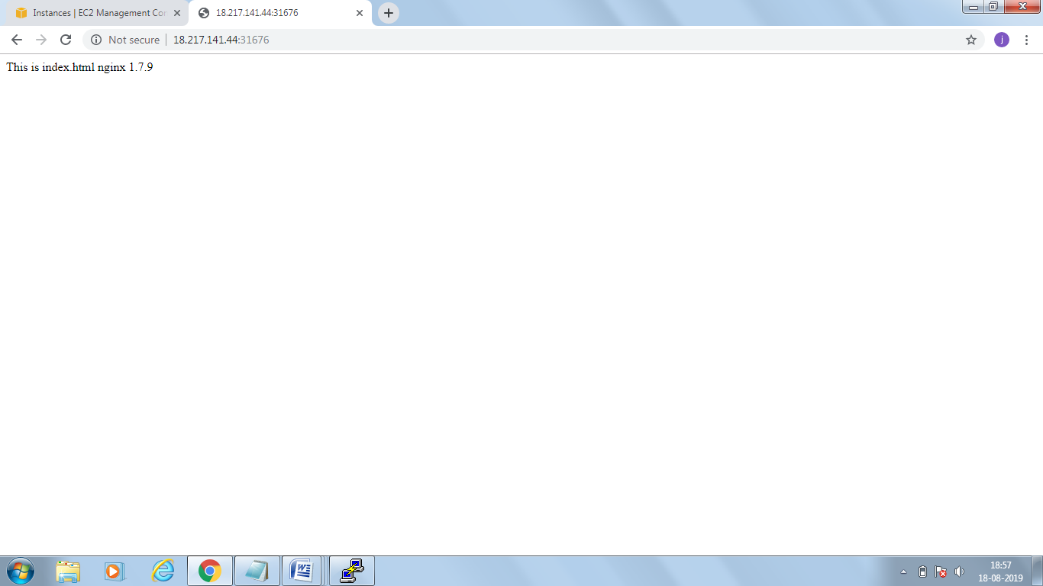

Now changing version of nginx

kubectl apply –f deployment-rollingupdate.yml <ymal file name>

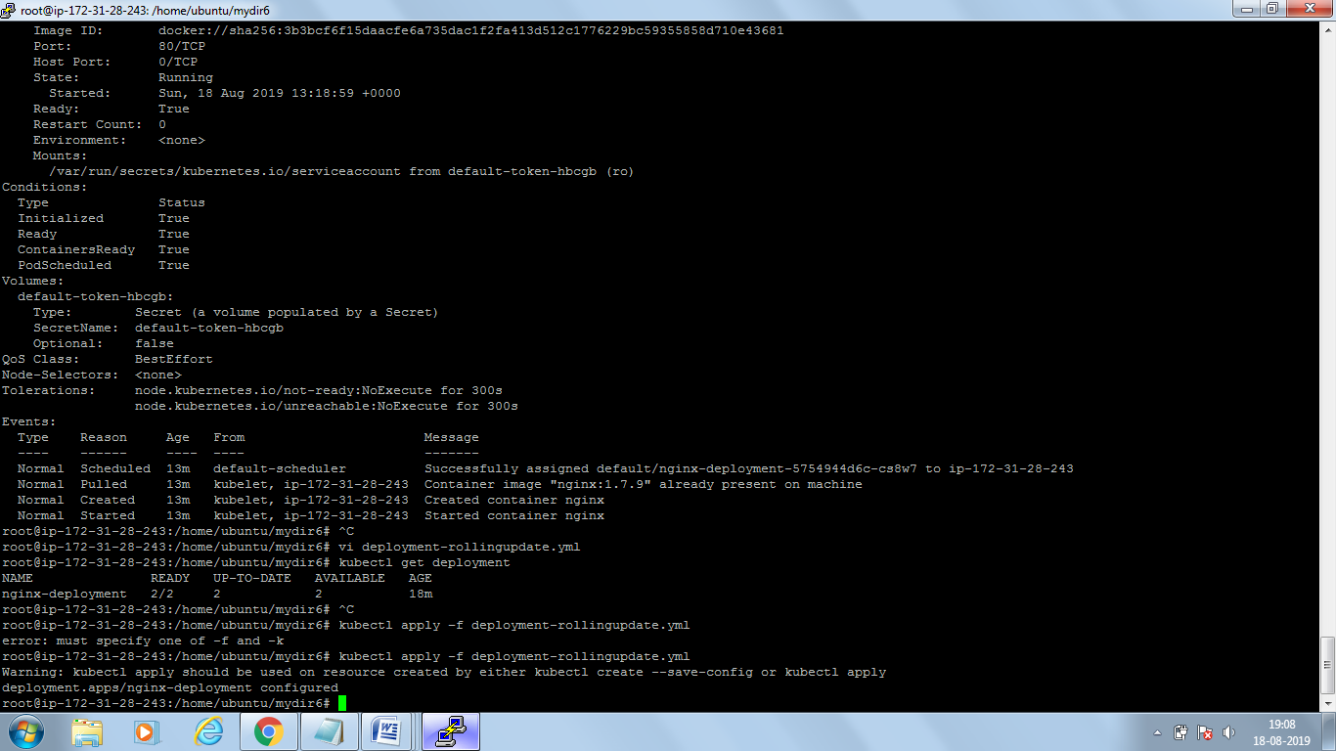

kubectl rollout status deployment/nginx-deployment

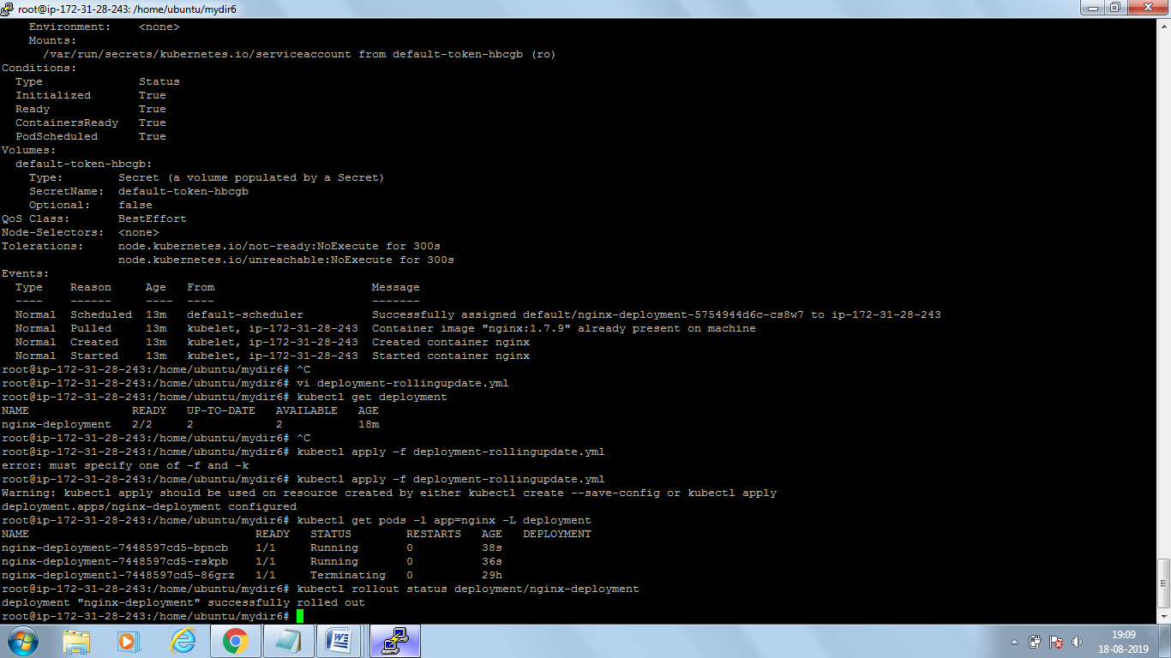

kubectl describe deployment nginx-deployment

check the image version carefully

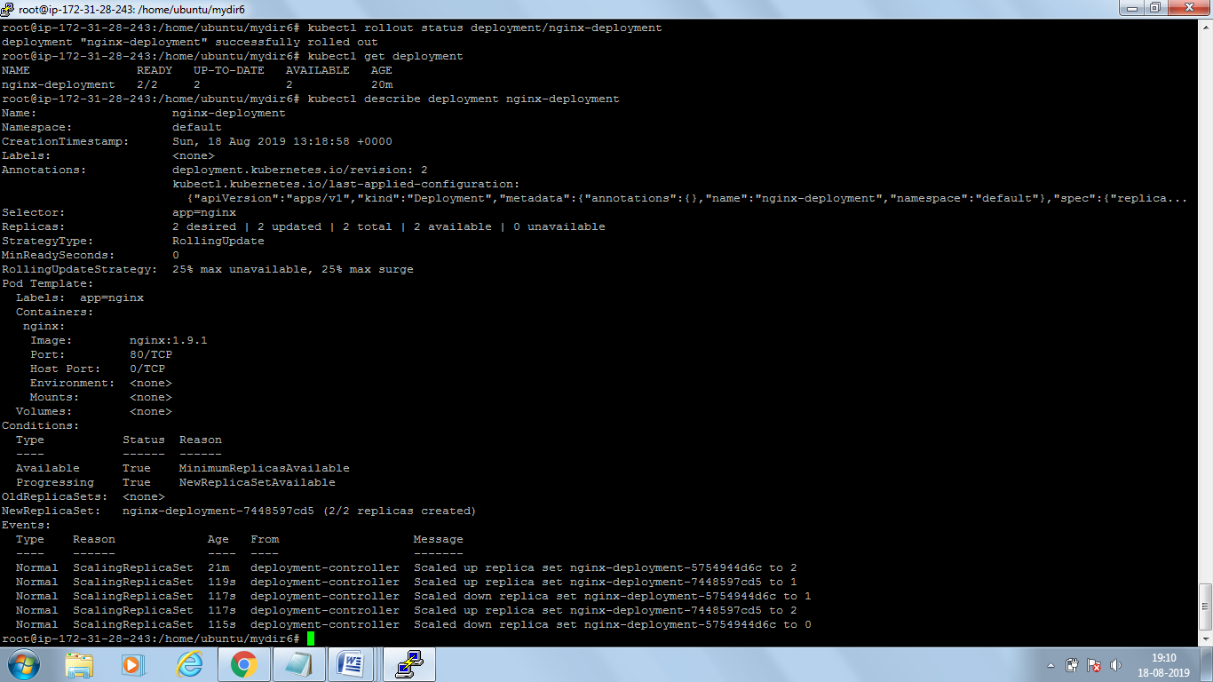

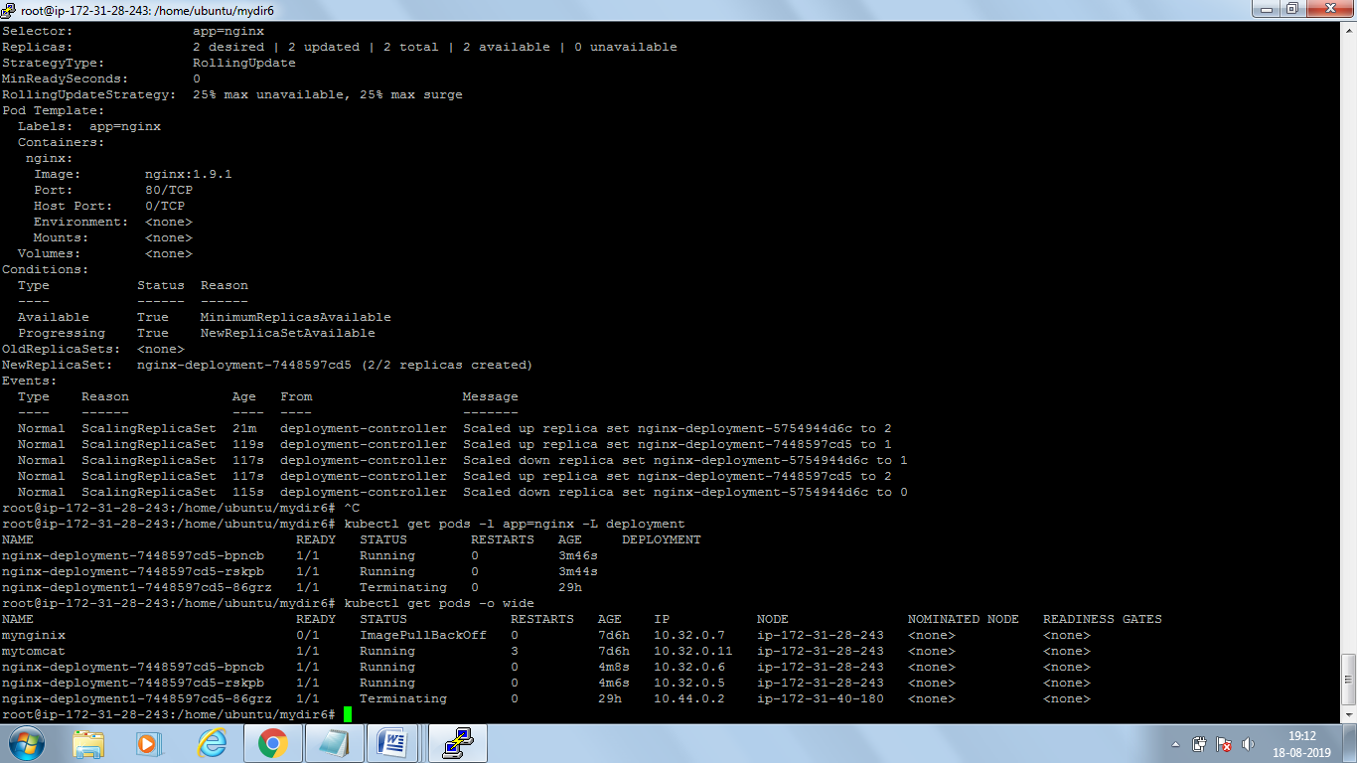

Now check in browser

